1. 
2. Components are some kind of instructions in the DOM. Once we place the selector of our component somewhere in our templates, at this point of time, we’re instructing angular to add the content of the component’s template and the business logic in our TypeScript code in this place where we use the selector.   
   This is our instruction, Angular place our component in this place and indeed components are directives but directives with a template,   
   But!!! There’re other directives without a template. Such as custom directive.  
   We typically add directives with an **attribute selector** but technically the selector of the directive can be configured just like the selector of the components   
   (Attribute Selector, Class Selector, Element Selector 🡸 CSS Selector)
3. 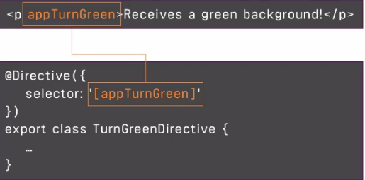  
   Here, we’re creating a directive with @Directive decorator to inform the angular that this class holds the directive and in the directive, there might be logic.  
   But there are a couple of directive built-in. Let’s see how to use them.